**CareConnect - Community Health and Donation Tracking System**

**Problem Statement:** Nonprofits running community healthcare programs struggle to connect donor contributions with patient outcomes. Separate systems for donations and health records cause poor transparency, reducing donor trust and retention. Healthcare workers also lack easy reporting on how funds improve health. A unified system is needed to track care, link it to donations, and provide real-time impact reporting.

**Phase 1: Problem Understanding & Industry Analysis**

**Requirement Gathering**

* **Identify needs**: donor tracking, patient records, campaigns.
* **Define objects**: Contact (Donor), Campaign (Program), Donation__c, Patient__c.
* **Capture key fields**: Donation amount, date, patient condition, treatment type.
* **Decide reports**: Total donations, patients served, campaign impact.
* **Automations**: Update donor’s total donations, send thank-you email.
* **Security**: Limit access by role (student users, admins).
* **Data entry**: Simple donation and patient forms.
* **Scalability**: Support recurring donations and future reports.
* **Offline needs**: Prepare Excel import templates.
* **Validation**: Required donation fields.

**Stakeholder Analysis**

* **Admins**: Configure Salesforce objects and automation.
* **Donors**: Need acknowledgment emails and impact reports.
* **Healthcare Volunteers**: Enter patient details and services delivered.
* **Program Managers**: Track campaign performance and outcomes.
* **Students/Developers**: Build and test functionality in Student Edition.
* **End Users:** Evaluate the capstone project’s usability.
* **Patients**: Benefit from tracked treatments and donations.

**Business Process Mapping**

* Donor pledges or gives → Donation__c record created.
* Donation links to donor (Contact) and campaign.
* Flow updates donor’s *Total Donations*.
* Thank-you email auto-sent to donor.
* Patients register → Patient__c record created.
* Treatments delivered → Treatment__c linked to patient & campaign.
* Campaign accumulates donations and patient records.
* Reports show donations per campaign, patients treated.
* Dashboard combines donor impact and program success.

**Industry-specific Use Case Analysis**

* **Healthcare**: Track patients, conditions, and treatments.
* **Nonprofit Donations**: Record and manage donor contributions.
* **Education/Student Projects**: Demonstrate data-driven social impact.
* **Community Outreach**: Link campaigns to both donations and patients.
* **Public Health**: Show vaccination drives or awareness programs.
* **Reporting Needs**: Measure funds raised vs. patients helped.
* **Automation**: Send reminders for recurring donations.
* **Security**: Ensure patient and donor confidentiality.

# Phase 2: Org Setup & Configuration Salesforce Editions

• The Student/Developer Edition is used to build the Community Health & Donation Tracking system. It offers core CRM features like custom objects for Patients, Donations, and Campaigns, plus automation via Flows. Though limited compared to Enterprise, it allows sufficient customization, reports, and dashboards to demonstrate nonprofit healthcare impact.

# Company Profile Setup

• The company profile defines organization settings for the nonprofit healthcare initiative. It stores details like organization name, primary contact, default time zone, and currency for donation tracking. Configuring this ensures all patient records, donation amounts, and campaign activities align with consistent organizational metadata and reporting standards across the project.

# Business Hours & Holidays

• Business hours define when healthcare workers and volunteers are active. Holidays identify days when campaigns or donation services pause. For example, clinic working hours can be set for reporting response times. Configuring this helps align donor service, patient care follow-ups, and automated communication with actual operational availability.

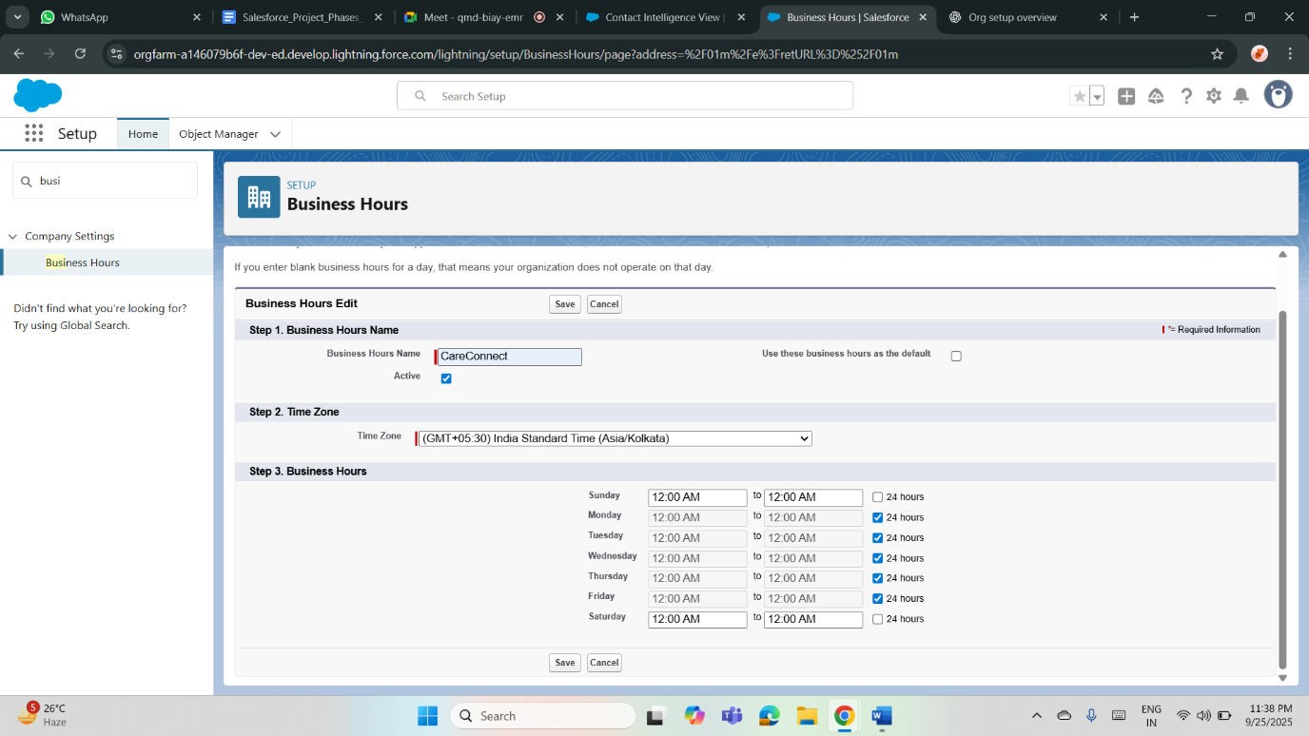

# Fiscal Year Settings

• Fiscal year settings standardize how donations and patient program outcomes are tracked financially. A custom fiscal year can be defined if nonprofit funding cycles differ from the calendar year. Aligning fiscal periods helps report total donations, resource allocation, and healthcare program performance in meaningful time-bound comparisons for stakeholders.

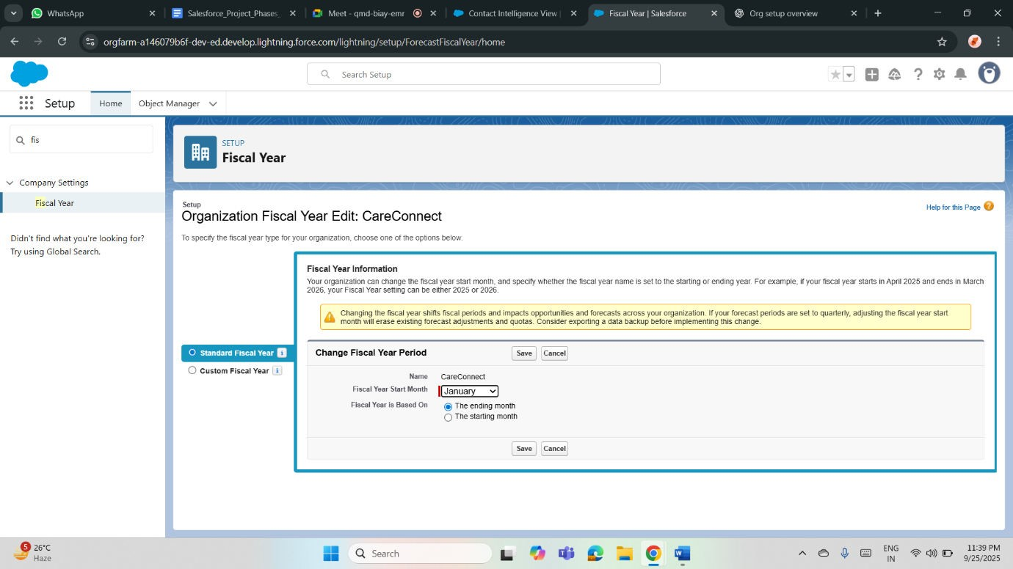

# User Setup & Licenses

• Different user accounts are created for admins, healthcare staff, and student developers. Licenses define access levels—full for admins, limited for staff. This ensures the right people manage donations, patient records, and campaigns. User setup allows role-based collaboration, while licenses ensure system functionality is used appropriately within edition limits.

# Profiles

• Profiles control what each user can do within the system. For example, healthcare staff may edit Patient records but only view Donations. Donor-facing profiles might access dashboards without editing rights. Custom profiles ensure sensitive health and donation data is protected while allowing efficient management of records relevant to each role.

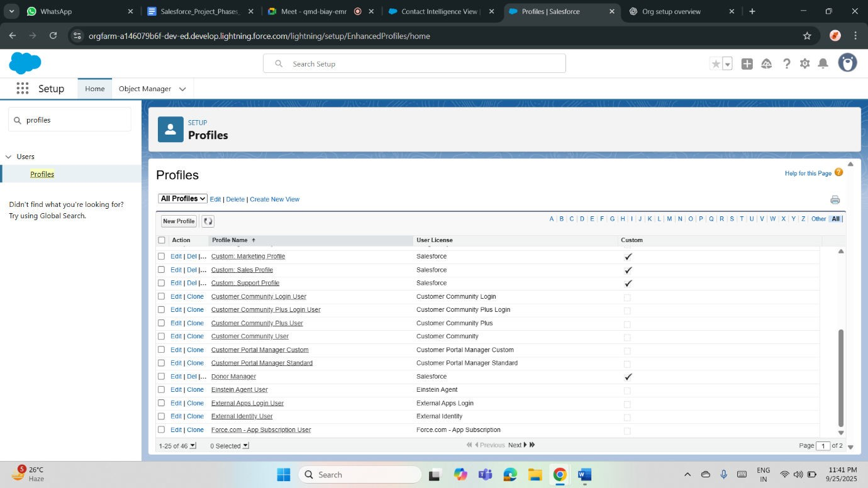

# Roles

• Roles define data visibility in the health and donation system. A hierarchical structure allows managers to view all data while staff only access their records. Example: Program Manager sees all patient treatments and donations; volunteers see only patients they served. Roles ensure controlled data visibility with accountability.

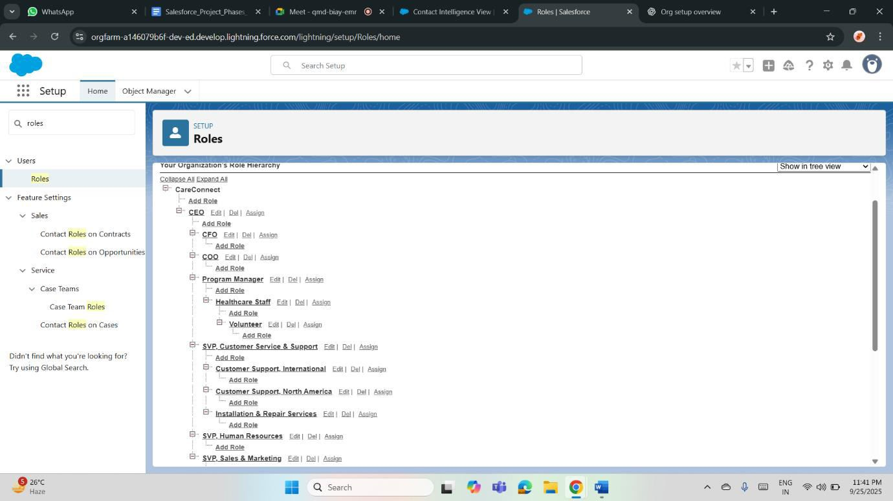

# Permission Sets

• Permission sets provide additional access without changing profiles. For example, a healthcare volunteer may need temporary access to enter donation records or view campaign dashboards. Assigning permission sets helps extend privileges flexibly, ensuring project scalability. They also allow selective testing of advanced features without overpermitting basic staff profiles.

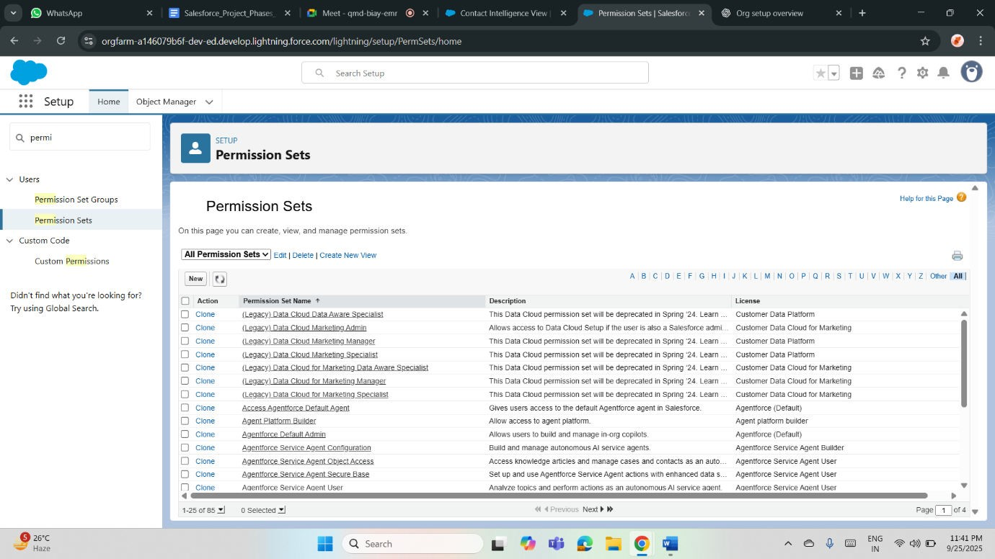

# OWD (Organization-Wide Defaults)

• OWD defines baseline record access. Patient__c and Donation__c objects can be set as Private to protect sensitive data. Campaigns may be Public Read-Only for broader access. This ensures donor, patient, and program data are secure by default, with visibility extended only through roles and sharing rules where appropriate.

# Sharing Rules

• Sharing rules grant broader access beyond OWD. Example: a donor manager role can be given Read-Only access to Donation__c, while healthcare managers can see linked Patient records. Campaign coordinators may share visibility for program outcomes. Sharing rules balance confidentiality with collaboration by extending controlled data visibility across teams.

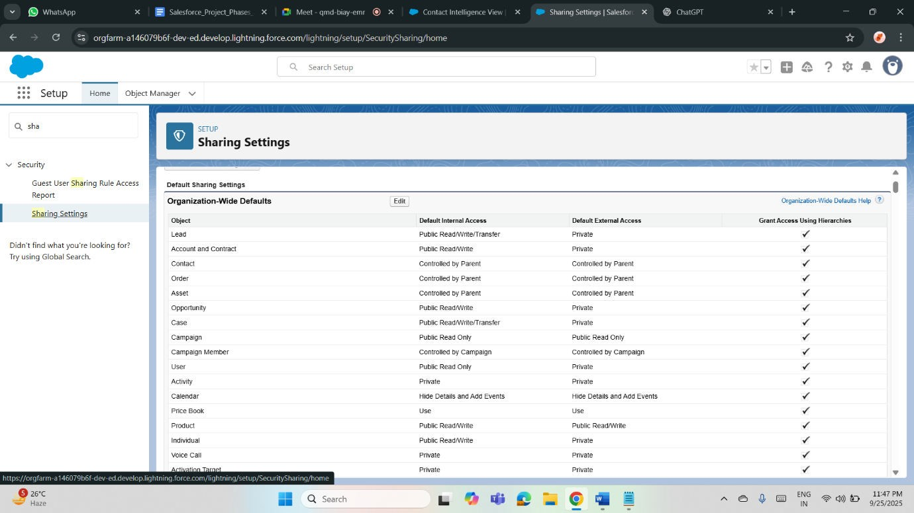

# Login Access Policies

• Login access policies define how users and admins securely access the system. Admins can temporarily log in as staff for troubleshooting patient or donation record issues. Configuring secure expiration periods for delegated access maintains data privacy. This ensures compliance, transparency, and smooth support for healthcare program operations.

# Dev Org Setup

• A Salesforce Developer Org is used to design, test, and validate the Community Health & Donation Tracking system. It includes standard and custom objects, automation via Flows, and dashboards. This environment enables experimentation and configuration of core features before moving into production or presenting the final capstone solution.

# Deployment Basics

• Deployment involves moving configuration from sandbox or developer org to the main environment. For the student project, deployment basics focus on change sets or metadata migration

**Phase 3: Data Modeling & Relationships**

**Standard & Custom Objects:**

Healthcare uses standard objects like Contacts for patients and Accounts for hospitals, while custom objects manage appointments or medical records. Donation systems use Opportunities for donations, Contacts for donors, and custom objects for campaigns or events. Combining standard and custom objects supports specialized workflows.

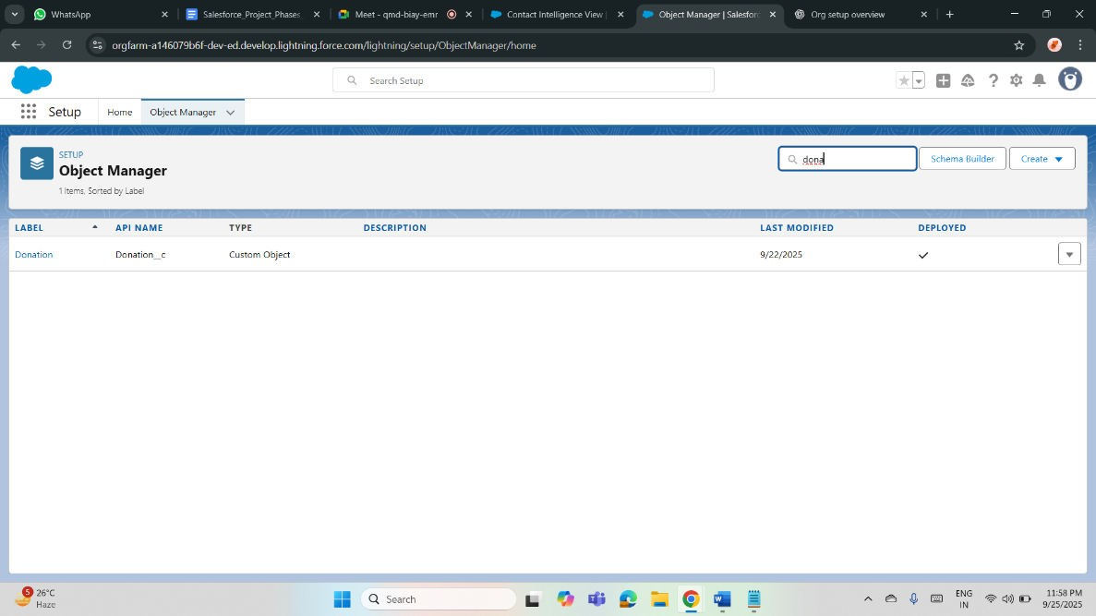

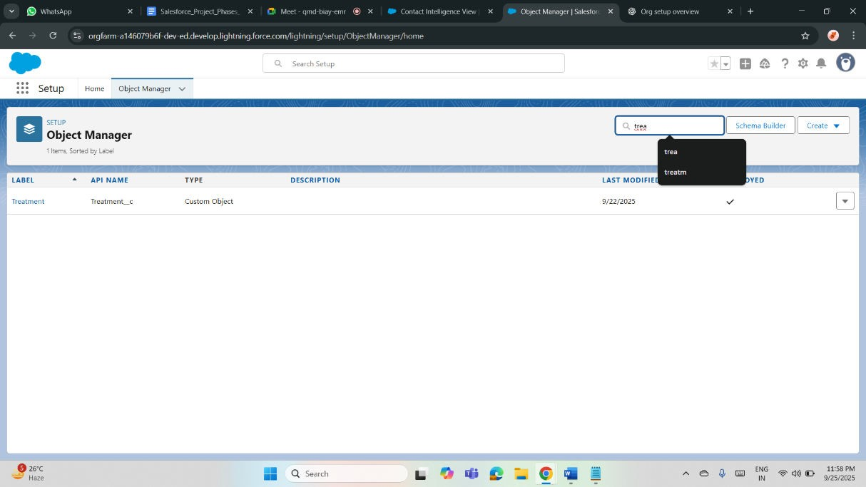

**Fields:**

Healthcare systems need fields for patient details (age, medical history, allergies). Donation systems need fields for donor preferences, contribution frequency, and pledge amount. Custom fields capture project-specific data, while validation rules ensure accuracy and compliance. Fields structure critical information and support reports and automation.

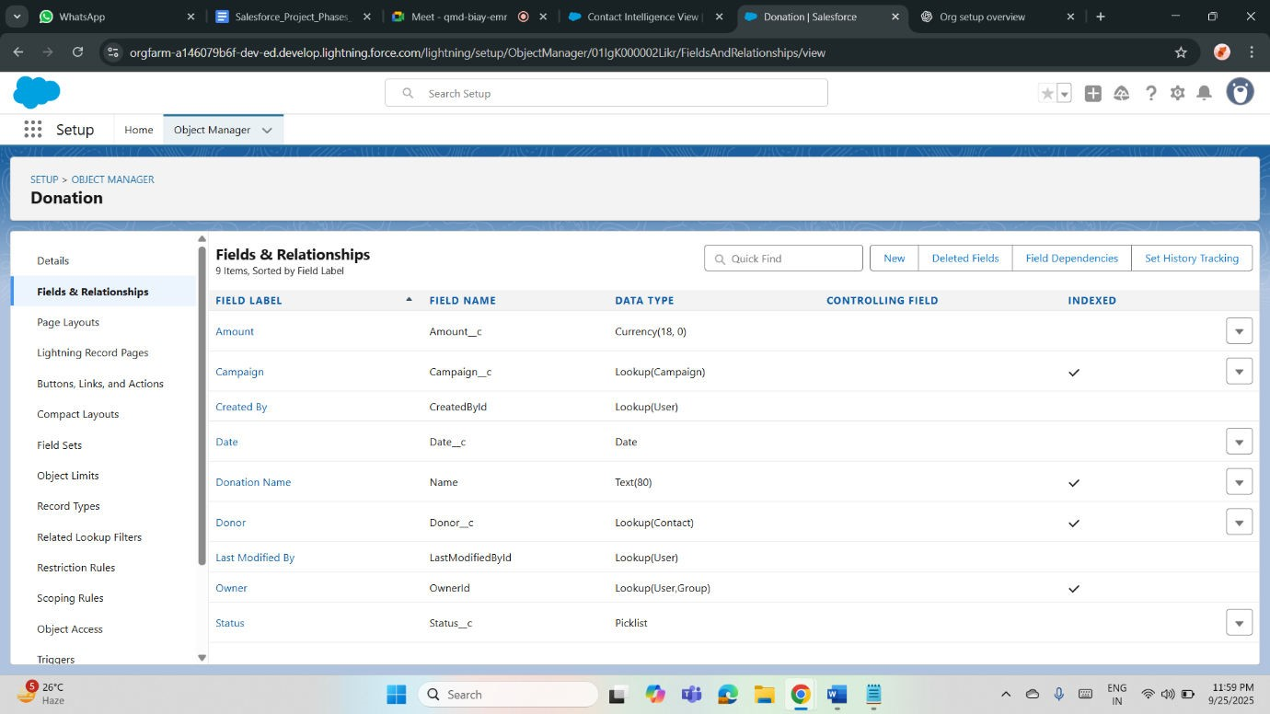

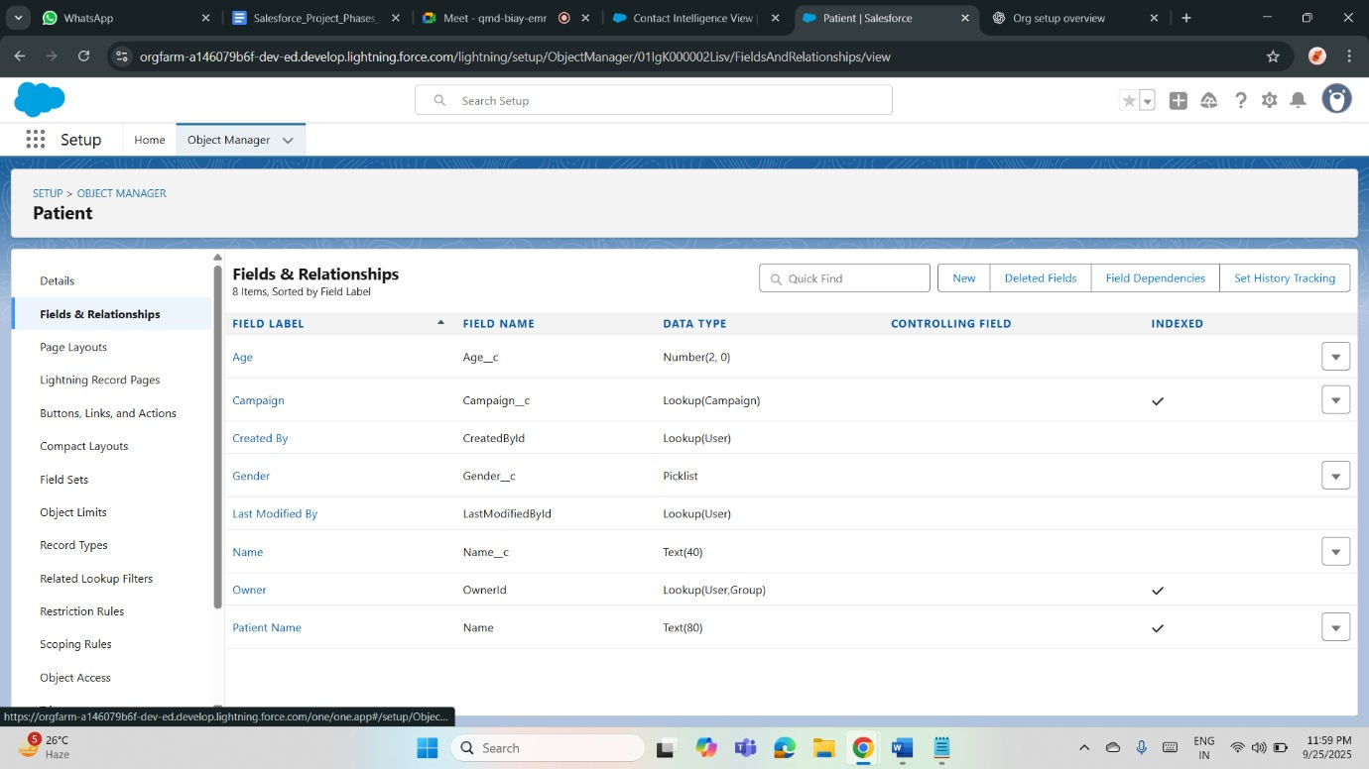

**Record Types:**

In healthcare, record types differentiate inpatient vs outpatient records or appointment types. In donation tracking, record types separate one-time donations from recurring pledges or corporate sponsorships. They allow customized processes, page layouts, and picklists to suit specific categories, improving usability and reporting.

**Page Layouts:**

Healthcare page layouts display vital signs, treatment plans, and contact information. Donation systems display donor history, pledge details, and related campaigns. Custom page layouts present role-based, relevant information to users, improving efficiency while ensuring sensitive or unnecessary details remain hidden.

**Compact Layouts:**

Compact layouts in healthcare highlight patient name, age, and emergency contact on mobile or quick views. In donation systems, donor name, pledged amount, and donation status appear at the top. Compact layouts deliver essential information at a glance, enhancing productivity and mobile usability.

**Schema Builder:**

Healthcare projects use Schema Builder to visualize patient, doctor, and treatment relationships. Donation systems map donors, donations, campaigns, and volunteers. Schema Builder provides a drag-and-drop interface to design, understand, and maintain data models, making relationships and dependencies easy to manage.

**Lookup vs Master-Detail vs Hierarchical Relationships:**

Healthcare uses lookup for patient–insurance links, master-detail for prescription–medication records, and hierarchical for internal staff management. Donation systems use lookup for donor–event relations, masterdetail for campaign–donation management, and hierarchical for organizing fundraiser teams. Choosing the right relationship ensures proper dependency and reporting.

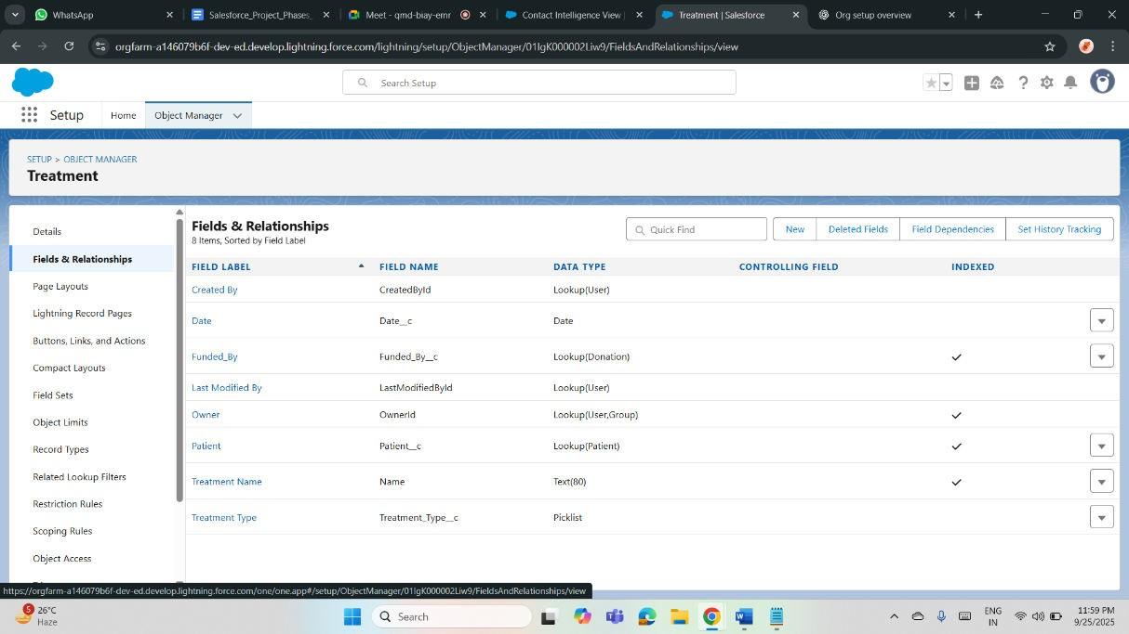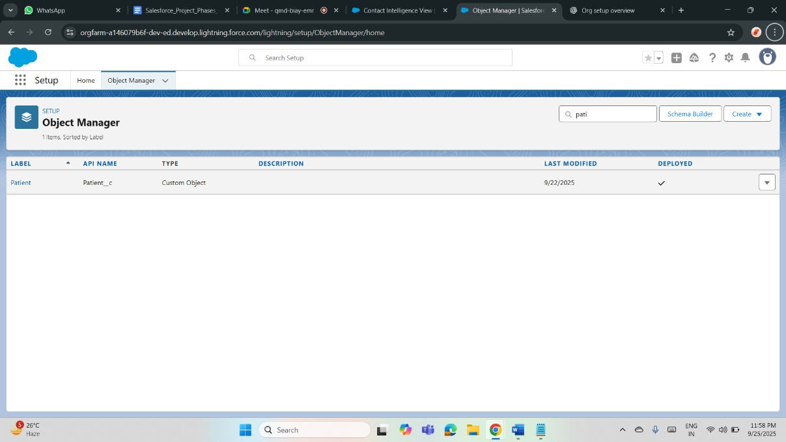

**Phase 4: Process Automation (Admin)**

**Validation Rules:**

Healthcare: Ensure accurate patient data by restricting invalid entries, like birthdates in the future or missing allergy information.

Donation: Enforce correct donation details, like preventing negative pledge amounts or ensuring mandatory donor contact information is filled. Validation rules maintain data accuracy and compliance in both systems.

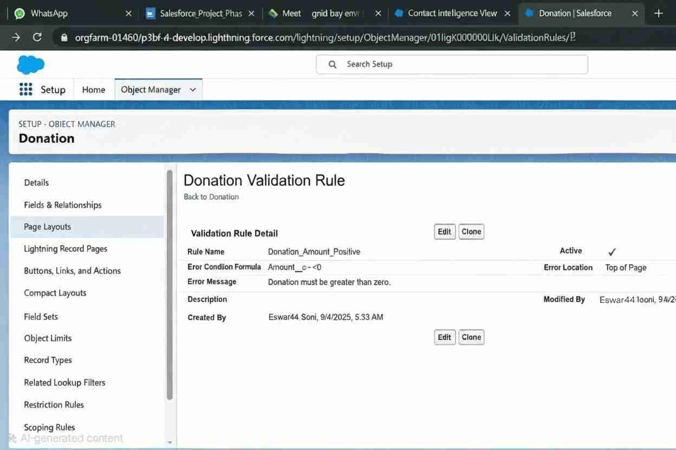

**Workflow Rules:**

Healthcare: Automate appointment reminders when a patient record is created or updated.

Donation: Send thank-you emails automatically when a donation is recorded. Workflow rules streamline repetitive tasks, improving communication and reducing manual effort in healthcare operations and donor management.

**Process Builder:**

Healthcare: Automate patient follow-up record creation when treatment status changes.

Donation: Automatically update donor status to “Active Supporter” after multiple contributions. Process Builder creates sophisticated, multi-step automation for managing healthcare processes and donor engagement workflows.

**Approval Process:**

Healthcare: Route treatment plan approvals to senior doctors before implementation.

Donation: Send large donations or grants for finance team approval. Approval processes enforce compliance, accountability, and oversight, ensuring critical actions receive proper authorization before execution.

**Flow Builder (Screen, Record-Triggered, Scheduled, Auto-launched):**

Healthcare: Screen flows collect patient intake details; record-triggered flows update treatment plans; scheduled flows send reminders; auto-launched flows assign follow-up tasks.

Donation: Screen flows guide volunteers in campaign setup; record-triggered flows update donor tiers; scheduled flows send pledge reminders; autolaunched flows assign campaign tasks.

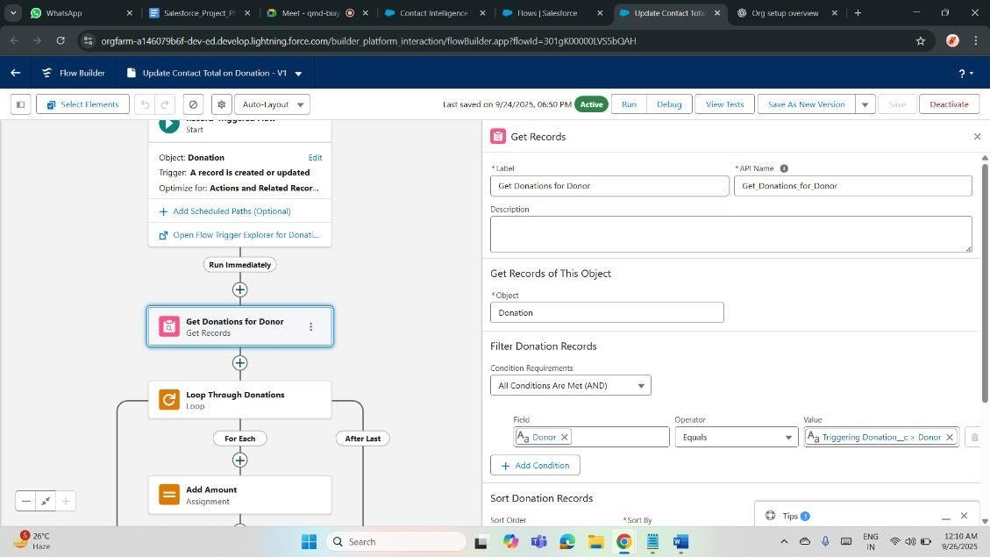

**Email Alerts:**

Healthcare: Automatically notify doctors of urgent patient test results. Donation: Send donors acknowledgment receipts and event invitations. Email alerts improve communication, ensuring stakeholders receive timely, consistent updates aligned with organizational needs.

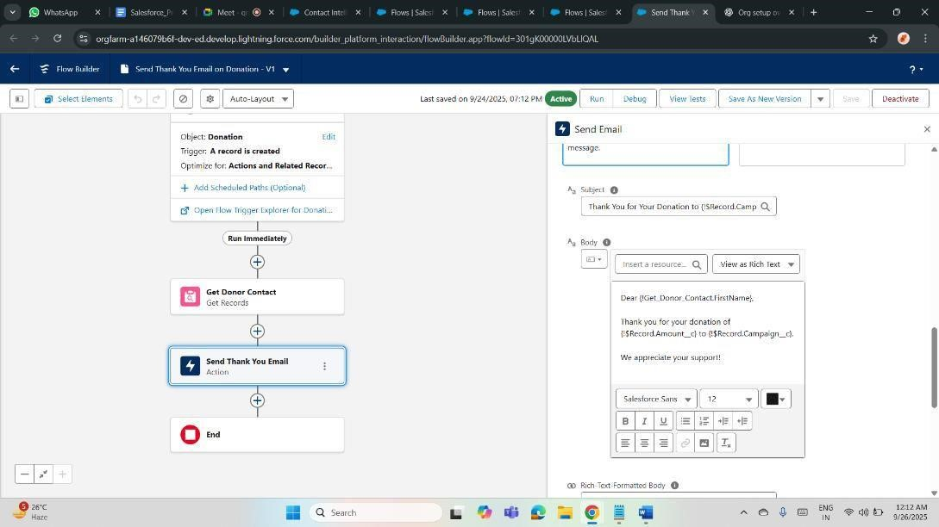

**Field Updates:**

Healthcare: Update patient status to “Discharged” after treatment completion. Donation: Change donation record status to “Received” after payment confirmation. Automated field updates keep data current and eliminate manual record adjustments.

**Tasks:**

Healthcare: Create tasks for follow-up consultations, medication schedules, or lab result reviews.

Donation: Generate tasks for donor outreach, pledge follow-ups, or campaign activities. Task automation keeps teams organized and ensures accountability.

**Custom Notifications:**

Healthcare: Send push notifications to staff when a patient is admitted to emergency.

Donation: Notify fundraisers when a high-value donation is pledged. Custom notifications enhance responsiveness by alerting users instantly within Salesforce or on mobile apps.

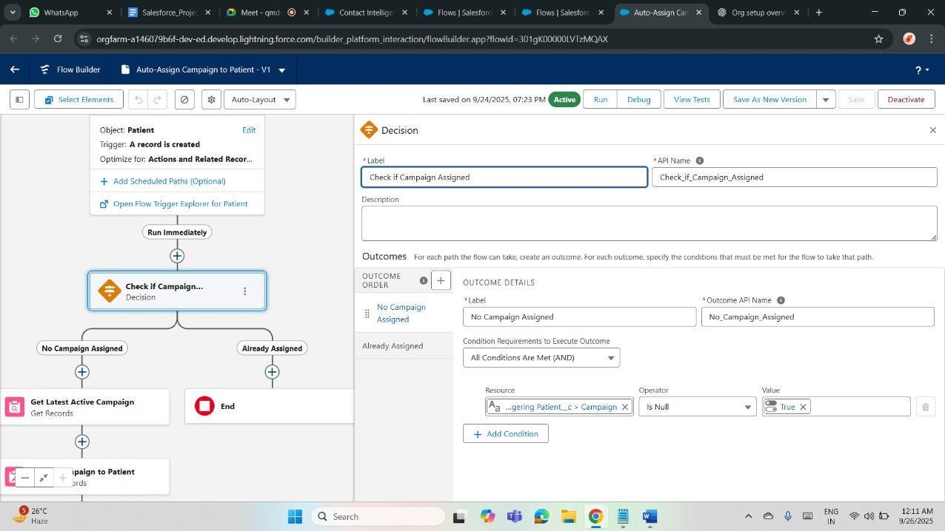

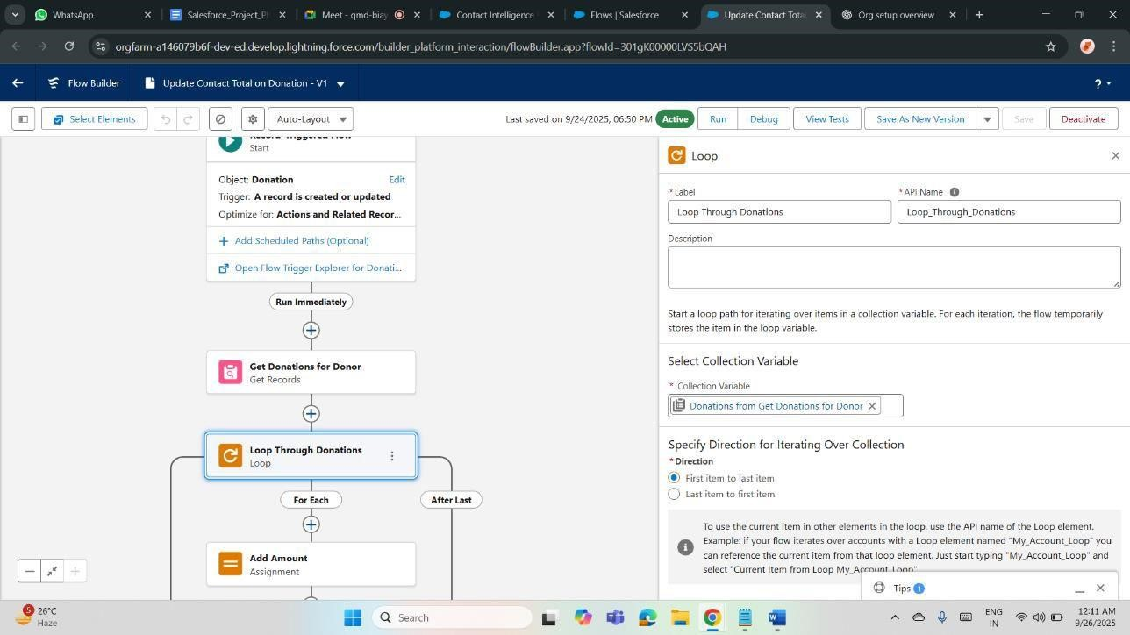

**Phase 5: Apex Programming (Developer)**

**Classes & Objects:**

Healthcare: Apex classes manage reusable logic like patient billing or appointment scheduling.

Donation: Classes handle donor segmentation or campaign budget calculations. Objects represent real-world entities (patients, donations), while classes encapsulate behaviors, ensuring structured, maintainable code across both systems.

**Apex Triggers (before/after insert/update/delete):**

Healthcare: Trigger alerts before inserting duplicate patient records, or after updating treatment completion.

Donation: Before-insert prevents duplicate donors, after-insert creates donor acknowledgment records. Triggers enforce data integrity and automate complex logic at database events.

**Trigger Design Pattern:**

Healthcare: Organizes triggers to manage patient workflows without recursion or redundancy.

Donation: Manages campaign-related updates systematically. The design pattern separates logic into handler classes, ensuring scalability, reusability, and compliance with Salesforce best practices.

**SOQL & SOSL:**

Healthcare: SOQL queries fetch patient medical history; SOSL retrieves emergency contacts across objects.

Donation: SOQL retrieves donation records by campaign; SOSL searches donor names across multiple fields. Both optimize data retrieval and reporting.

**Collections (List, Set, Map):**

Healthcare: Lists store multiple appointments; Sets prevent duplicate patient IDs; Maps link doctor IDs with patients.

Donation: Lists store donor records; Sets ensure unique campaign names; Maps connect donors with their pledges. Collections manage data efficiently in bulk operations.

**Control Statements:**

Healthcare: Conditional logic routes critical lab results to doctors immediately. Donation: Loops process multiple donations; IF-ELSE statements apply discounts for recurring pledges. Control statements guide code flow, making automation intelligent.

**Batch Apex:**

Healthcare: Processes bulk patient records for billing or insurance claims. Donation: Updates thousands of donor records during annual campaign reconciliation. Batch Apex handles large datasets asynchronously without hitting governor limits.

**Queueable Apex:**

Healthcare: Chain background jobs like scheduling patient reminders.

Donation: Run complex donor segmentation logic asynchronously. Queueable Apex supports job chaining and structured asynchronous processing beyond Batch Apex.

**Scheduled Apex:**

Healthcare: Automates daily patient checkup reminders or medication reports. Donation: Schedules monthly donor pledge reminders or quarterly fundraising summaries. Scheduled Apex executes recurring tasks at defined intervals.

**Future Methods:**

Healthcare: Send patient lab result notifications asynchronously.

Donation: Call external payment gateways in the background. Future methods free up synchronous transactions by running time-consuming operations later.

**Exception Handling:**

Healthcare: Catch errors in prescription workflows to prevent wrong medicine entries.

Donation: Handle failed donation transactions gracefully with user-friendly messages. Exception handling improves system reliability and user trust.

**Test Classes:**

Healthcare: Validate patient workflows, ensuring triggers and classes work correctly.

Donation: Test donor creation, campaign automation, and batch processes. Test classes ensure code quality, 75% coverage, and compliance with Salesforce deployment requirements.

**Asynchronous Processing:**

Healthcare: Run intensive data jobs like medical history analysis asynchronously.

Donation: Process thousands of donations or generate pledge reports in the background. Asynchronous processing improves performance, avoids limits, and maintains user experience.

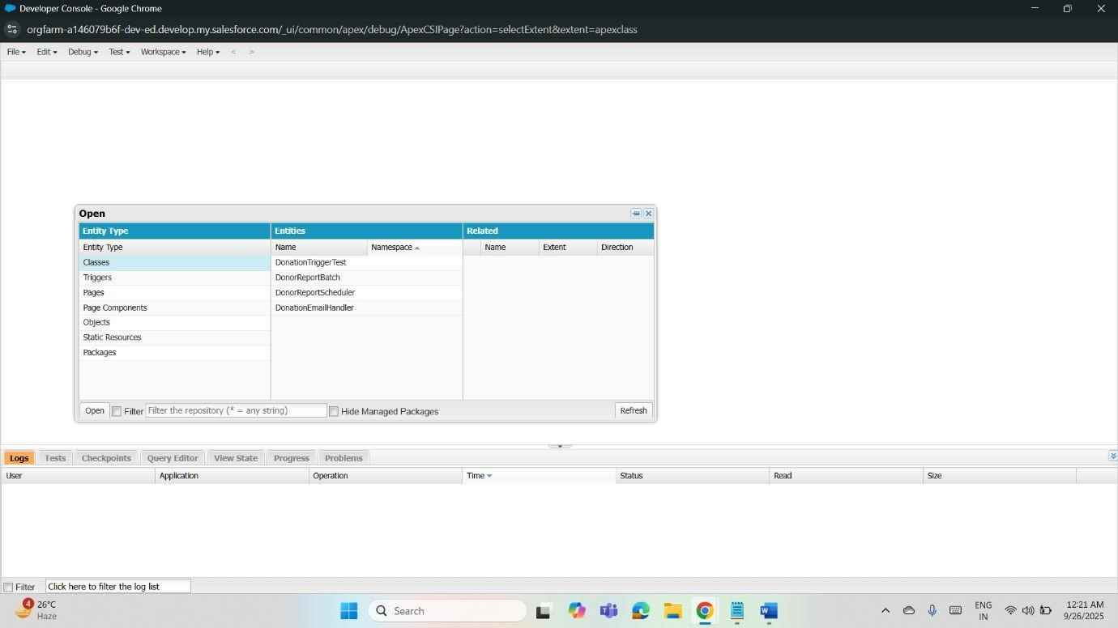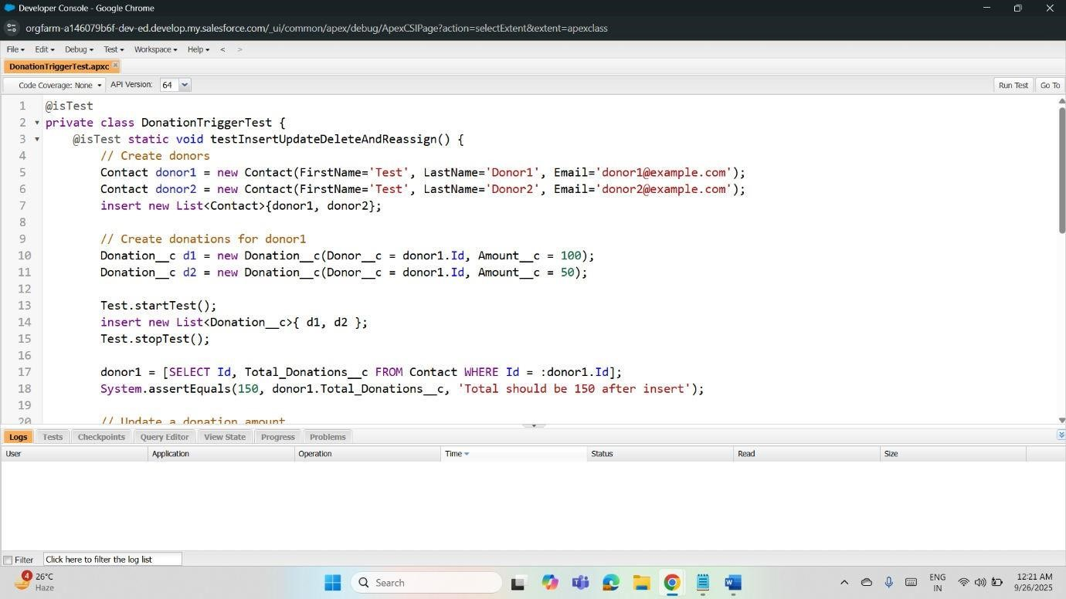

**Phase 6: User Interface Development**

**Lightning App Builder:**

Healthcare: Build custom apps for patient management dashboards, combining charts, lists, and components.

Donation: Create fundraising apps displaying donor trends and campaign performance. App Builder lets admins configure drag-and-drop pages without coding.

**Record Pages:**

Healthcare: Customize patient record pages with related appointments, lab results, and doctor notes.

Donation: Display donor profiles with pledge history, related campaigns, and contact info. Record pages provide role-specific data visibility.

**Tabs:**

Healthcare: Add custom tabs for prescriptions, lab results, or appointments. Donation: Tabs organize campaigns, donations, and volunteers. Tabs make navigation easy, ensuring users quickly access relevant records.

**Home Page Layouts:**

Healthcare: Show doctors dashboards with upcoming appointments, urgent alerts, and KPIs.

Donation: Display fundraiser metrics, donor engagement charts, and active campaigns. Home layouts deliver personalized, actionable insights at login.

**Utility Bar:**

Healthcare: Add quick access to patient search, chat, or case logging.

Donation: Include shortcuts for donor lookup, campaign status, and notes. The utility bar provides persistent tools across the app.

**LWC (Lightning Web Components):**

Healthcare: Create reusable components for live patient monitoring or appointment booking.

Donation: Build donor pledge calculators or event signup widgets. LWCs deliver modern, responsive UI with faster performance.

**Apex with LWC:**

Healthcare: Use Apex to fetch patient history or update treatment plans securely.

Donation: Call Apex to process bulk donations or generate reports. Apex integrates server-side logic with LWC for dynamic, data-driven experiences.

**Events in LWC:**

Healthcare: Trigger events when updating vitals so related components refresh instantly.

Donation: Fire events when pledges are added to update donor totals. Events enable communication between LWC components for seamless interactivity.

**Wire Adapters:**

Healthcare: Wire Apex or Salesforce data to show real-time patient records. Donation: Use wire adapters to display live donor contributions or campaign stats. They provide reactive, automatic data binding without imperative calls.

**Imperative Apex Calls:**

Healthcare: Fetch filtered patient records on button click for doctors. Donation: Execute donor segmentation logic on demand. Imperative calls give more control than wire adapters, allowing custom actions and error handling.

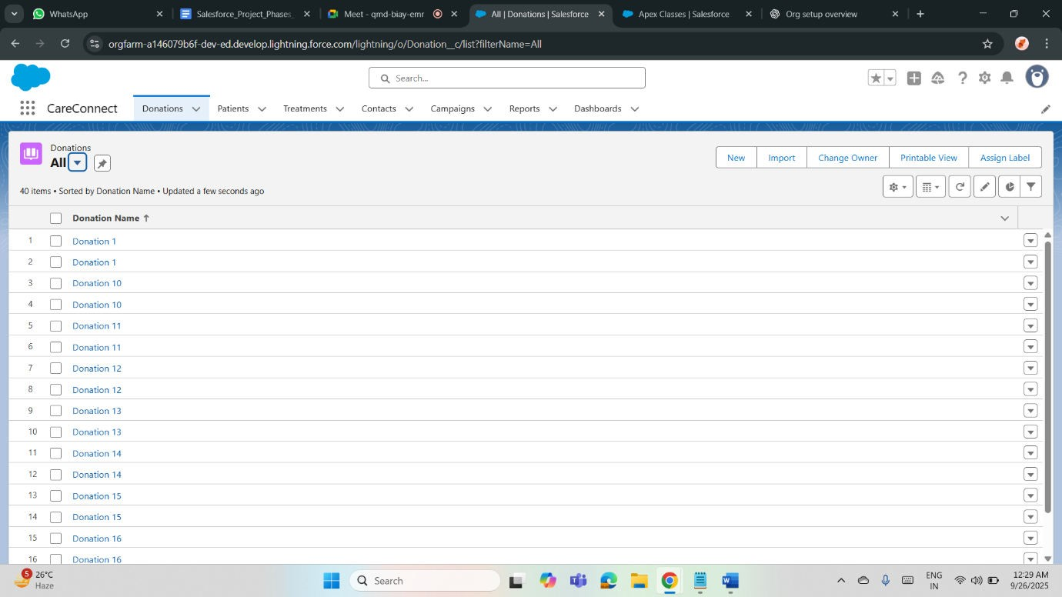

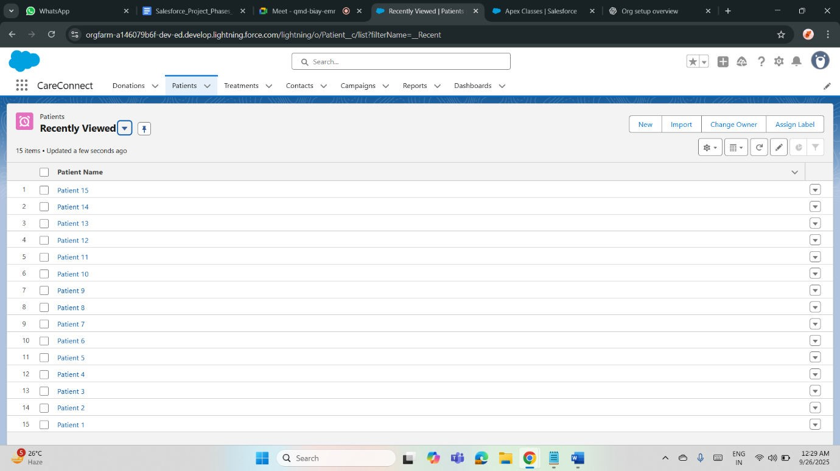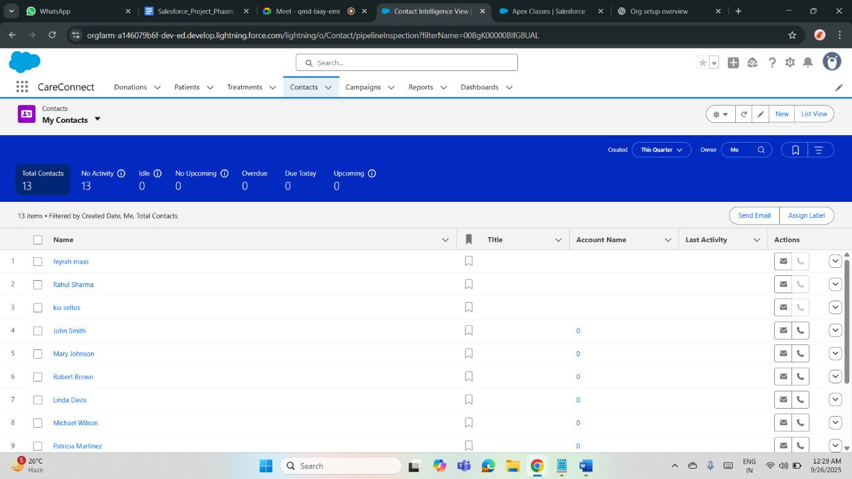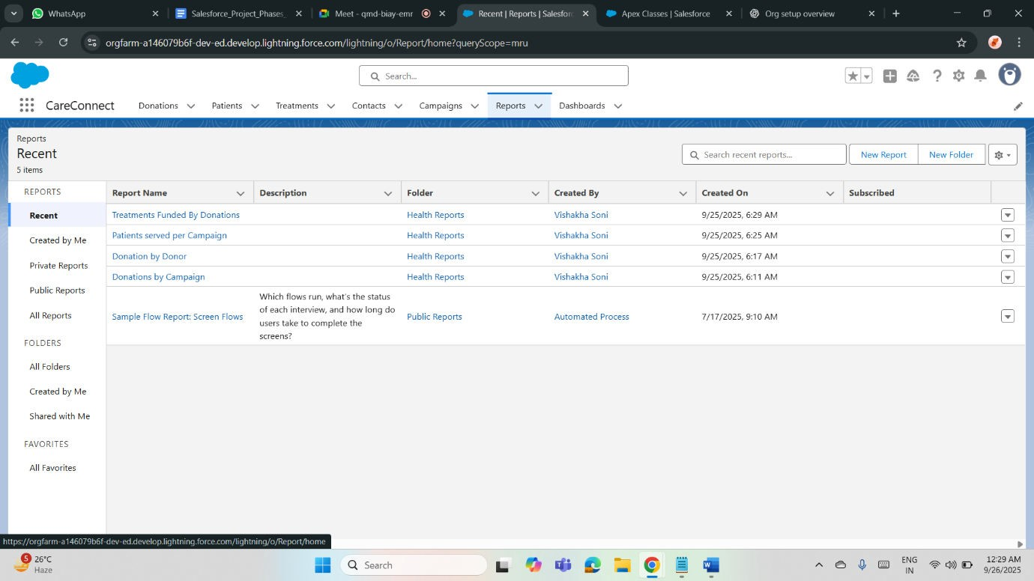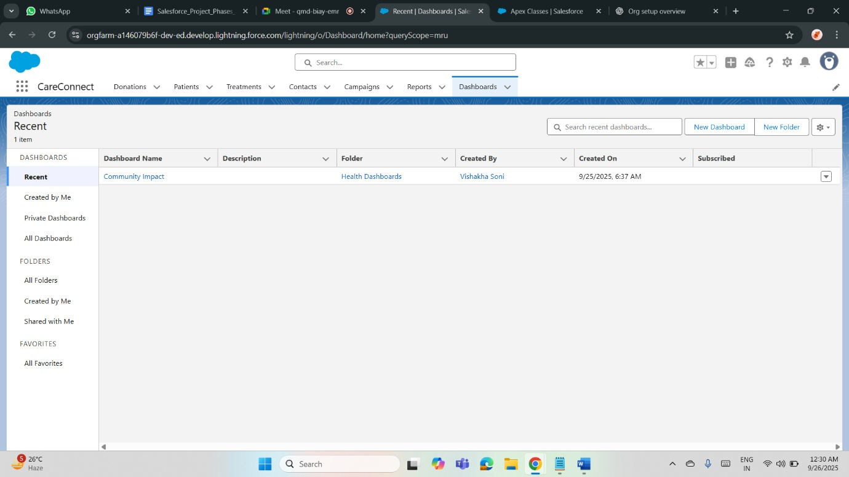

**Phase 7: Integration & External Access**

**Named Credentials:**

Healthcare: Securely store authentication for connecting to lab systems or pharmacy APIs.

Donation: Manage payment gateway authentication for donation processing. Named Credentials simplify callouts by handling endpoints and authentication in one configuration, reducing hardcoding and improving security.

**External Services:**

Healthcare: Integrate external diagnostic systems via schema-driven APIs for lab result submissions.

Donation: Connect external fundraising apps to process donations. External Services allow declarative access to APIs through Flow without custom Apex.

**Web Services (REST/SOAP):**

Healthcare: REST APIs fetch patient records, SOAP integrates with legacy hospital systems.

Donation: REST APIs connect with donor portals; SOAP syncs with financial systems. Salesforce supports both, enabling flexible system interoperability.

**Callouts:**

Healthcare: Perform callouts to external pharmacy databases for drug availability.

Donation: Make callouts to financial institutions to verify large donations.

Callouts allow Salesforce to communicate with external systems in real-time.

**Platform Events:**

Healthcare: Notify care teams instantly about patient emergencies.

Donation: Trigger real-time alerts when a major donation is pledged. Platform Events enable pub-sub architecture, ensuring event-driven communication across systems.

**Change Data Capture (CDC):**

Healthcare: Capture patient record changes (diagnosis updates) for downstream systems.

Donation: Stream donation updates to analytics tools in real time. CDC publishes record changes as events, improving integration and data accuracy.

**Salesforce Connect:**

Healthcare: Access external EHR (Electronic Health Record) systems without storing data in Salesforce.

Donation: View external donor registry data in real time. Salesforce Connect provides virtual objects, enabling seamless integration with external data sources.

**API Limits:**

Healthcare: Monitor API usage to prevent overuse during patient data sync.

Donation: Ensure bulk donation imports respect limits. API limits protect Salesforce performance, requiring optimization of integrations and batching strategies.

**OAuth & Authentication:**

Healthcare: Use OAuth for secure patient data sharing with third-party apps. Donation: Authenticate fundraising portals securely with Salesforce. OAuth ensures secure token-based access, protecting sensitive healthcare and donor data.

**Remote Site Settings:**

Healthcare: Allow Salesforce to communicate with trusted external lab or insurance systems.

Donation: Enable callouts to payment processors or donor portals. Remote Site Settings whitelist external endpoints, ensuring only approved integrations can interact with Salesforce.

**Phase 8: Data Management & Deployment**

**Data Import Wizard:**

Healthcare: Import patient records, appointments, or staff data with guided steps.

Donation: Import donor contacts, pledges, and campaign contributions. Best for small to medium datasets, it’s simple and user-friendly but has limited object support compared to Data Loader.

**Data Loader:**

Healthcare: Bulk-load large patient histories or insurance claims securely. Donation: Import/export thousands of donor or pledge records. Data Loader handles massive data volumes, supports scheduling, and allows complex field mappings beyond Import Wizard’s limits.

**Duplicate Rules:**

Healthcare: Prevent duplicate patient profiles that could risk treatment accuracy.

Donation: Stop duplicate donor entries to maintain clean fundraising records. Duplicate Rules identify, block, or allow duplicates with alerts, improving data quality.

**Data Export & Backup:**

Healthcare: Schedule weekly exports of medical data for compliance and recovery.

Donation: Export donor and campaign data for audit purposes. Regular backups protect against accidental loss, corruption, or regulatory breaches.

**Change Sets:**

Healthcare: Deploy custom objects, validation rules, or flows for new patient workflows from sandbox to production.

Donation: Move campaign automation, page layouts, or donation workflows safely. Change Sets ensure tested features go live without manual reconfiguration.

**Unmanaged vs Managed Packages:**

Healthcare: Use managed packages for secure hospital apps with vendor updates; unmanaged for internal prototypes like appointment trackers. Donation: Managed packages for donation platforms, unmanaged for temporary custom fundraising apps. Managed packages are vendormaintained; unmanaged are editable, ideal for development.

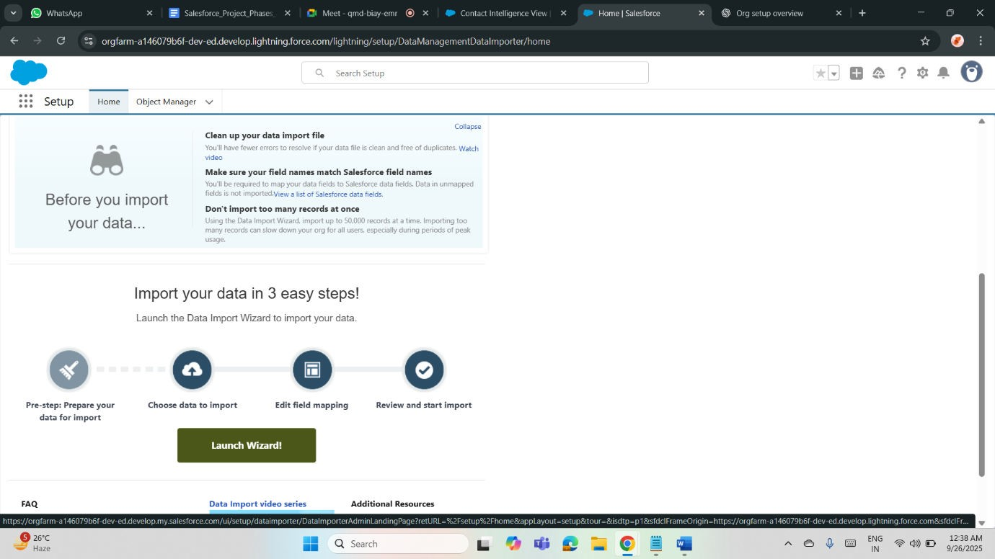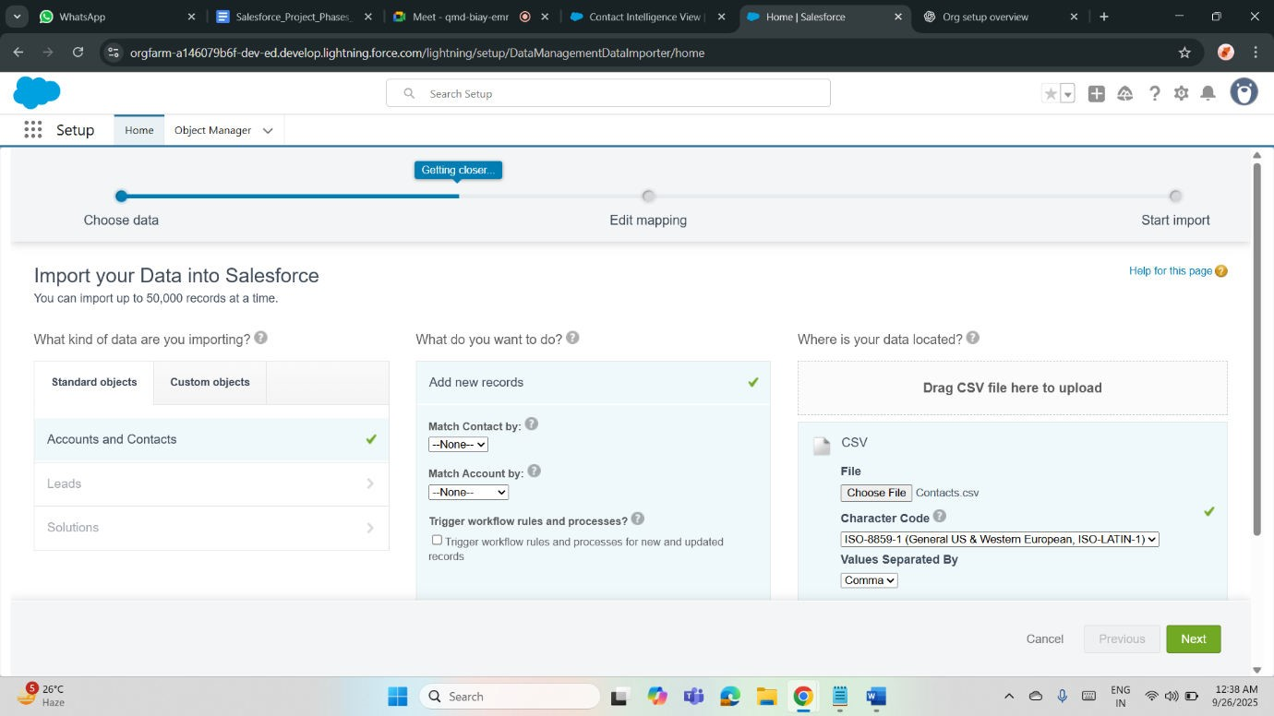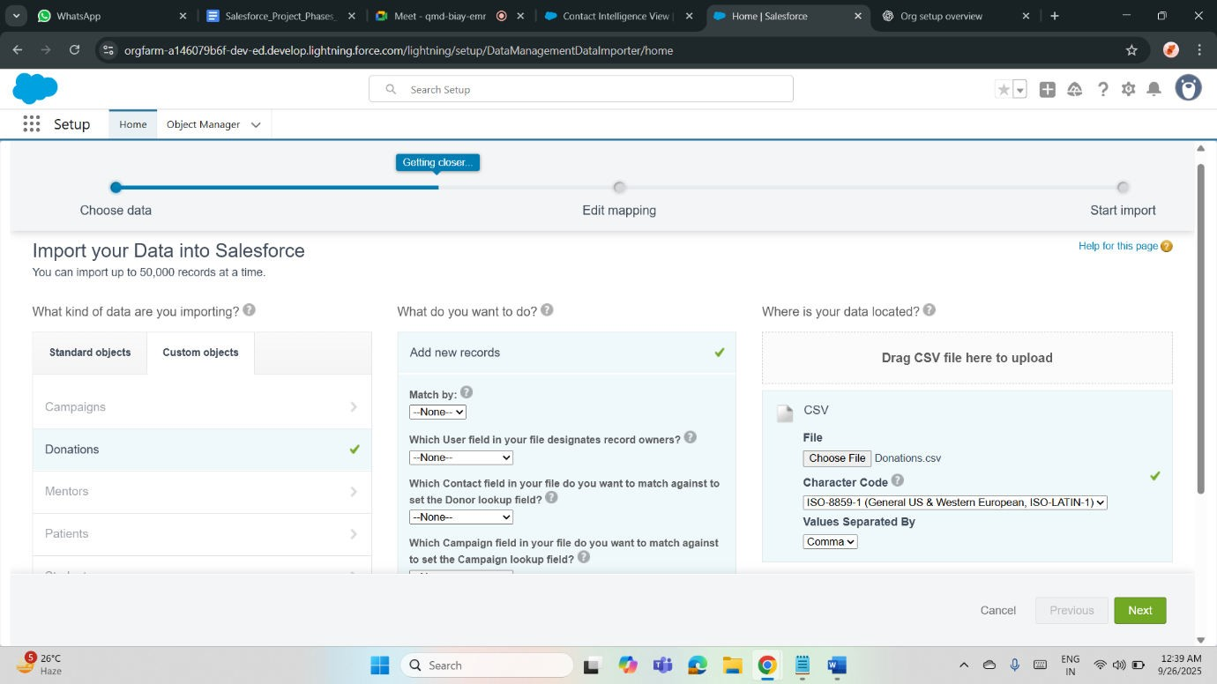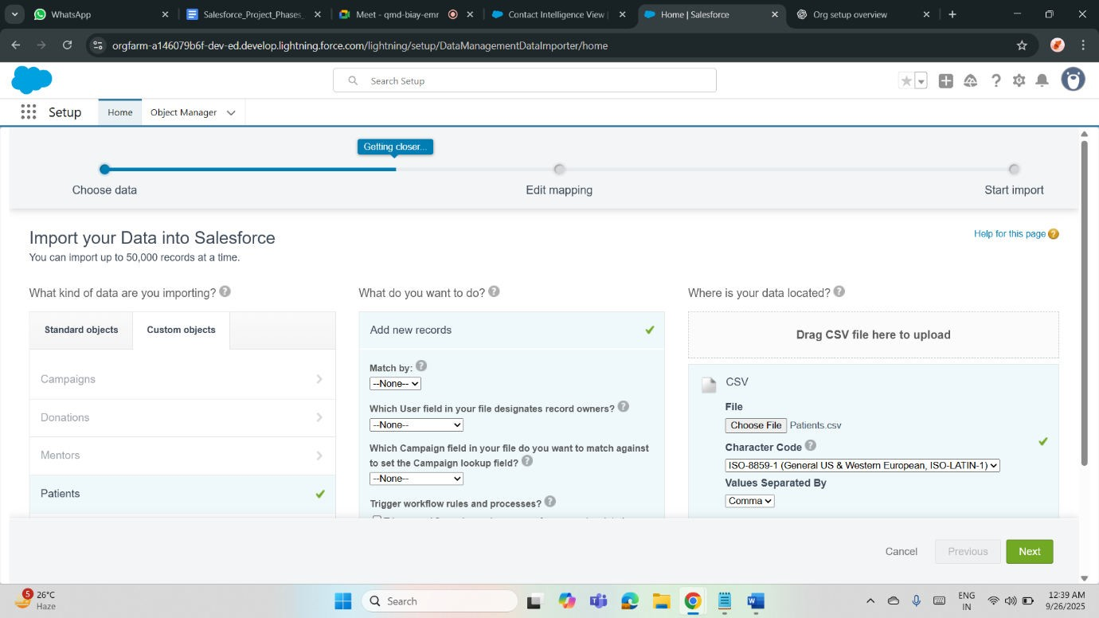

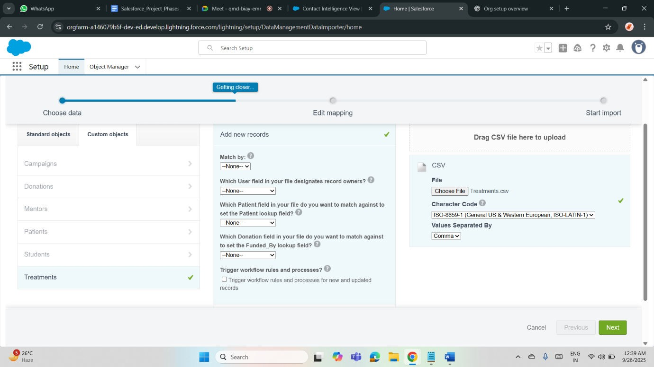

**Phase 9: Reporting, Dashboards & Security Review**

**Reports (Tabular, Summary, Matrix, Joined):**

Healthcare: Tabular lists patient visits, Summary groups by doctors, Matrix compares treatments across departments, Joined combines billing and appointments.

Donation: Tabular lists donor records, Summary groups by campaign, Matrix compares regional donations, Joined merges donor pledges and volunteer activity. Different report formats provide flexible analysis.

**Report Types:**

Healthcare: Custom report types combine patients with lab results or doctors. Donation: Link donors, donations, and campaigns for holistic insights. Report types define available objects and fields, ensuring meaningful data relationships for analysis.

**Dashboards:**

Healthcare: Display KPIs like admitted patients, treatment success rates, and appointment load.

Donation: Show campaign progress, donor engagement, and fundraising goals. Dashboards visualize key metrics for quick decision-making.

**Dynamic Dashboards:**

Healthcare: Doctors see only their patient data on dashboards.

Donation: Fundraisers view only campaigns they own. Dynamic dashboards personalize insights while maintaining data security, ideal for role-specific visibility.

**Sharing Settings:**

Healthcare: Make patient data private for compliance while sharing hospitalwide announcements.

Donation: Keep donor details restricted but share campaign performance broadly. Sharing settings balance collaboration with data confidentiality.

**Field Level Security (FLS):**

Healthcare: Restrict sensitive fields like medical history to authorized clinicians only.

Donation: Hide donor payment details from general staff. FLS enforces granular protection of critical fields beyond object-level security.

**Session Settings:**

Healthcare: Shorter timeouts protect patient data on shared hospital devices. Donation: Session policies prevent unauthorized donor record access during idle times. Session settings strengthen access security across both domains.

**Login IP Ranges:**

Healthcare: Allow access only from hospital or clinic networks.

Donation: Restrict fundraising staff logins to trusted office or VPN locations. IP ranges prevent unauthorized external access, enhancing system security.

